RFM Customer Segmentation Analysis
Identifying High-Value and At-Risk Customers in the Online Retail II Dataset
Prepared by Muhammad Shahan
SQL (MySQL) · Python (pandas, scikit-learn) · Power BI
August 2026

Table of Contents Page No.

1. Executive Summary: 2
2. Business Question & Objective: 2
3. Data & Methodology: 2
4. Finding 1: Choosing K — The Elbow Method: 3
5. Finding 2: Four Segments and a Skewed Customer Base: 3
6. Finding 3: A Seasonal Pattern and the At-Risk Opportunity: 4
7. Recommendations: 5
8. Known Limitations & Next Steps: 5
9. Conclusion: 5
10. Technical Appendix: Supporting Queries: 6
11. Reference Date: 6
12. Recency: 6
13. Frequency: 6
14. Monetary: 7

Executive Summary:
This project divides the customer base of a real UK online retailer (2009-2011 transaction data) using RFM analysis — Recency, Frequency and Monetary value, combined with K-Means clustering to identify distinct, actionable customer groups. Of 5,837 customers with positive net spend, clustering revealed four segments: a large base of Core Customers (3,837, 66%), a substantial At Risk / Lost group (1,954, 33%) who have not purchased in well over a year and two small but highly disproportionate high-value groups 42 "Wholesale - High Value" customers and just 4 "Wholesale - Extreme" accounts, whose average spend and order frequency vastly exceed the typical customer, despite representing under 1% of the customer base.
The analysis indicates two key opportunities: high-value customers should receive personalized attention to maintain their loyalty, while At-Risk customers should be targeted with re-engagement strategies to recover potential lost revenue.

Business Question & Objective:
Objective: Divides the customer base using purchase behaviour alone (how recently, how often, and how much each customer buys) to identify which customers are most valuable, which are at risk of churning, and whether any groups require a different business approach than the rest.
RFM was chosen as the analytical foundation because it requires no external data beyond transaction history, is easy to explain to a stakeholder, and forms a natural basis for unsupervised clustering, letting the data reveal segment boundaries rather than relying on arbitrary manual thresholds.

Data & Methodology:
- Data source: UCI "Online Retail II" dataset — real invoice-level transactions from a UK-based online retailer, ~1.07 million rows across two years (2009-2011).
- Data preparation (MySQL): Imported via Python/pandas rather than raw LOAD DATA INFILE, to correctly handle the file's latin1 encoding (currency symbols) and UK-format dates. Indexed customer_id column, invoice and invoice_date given the dataset's size.
- Feature engineering (SQL): Calculated Recency (days since last purchase, relative to the dataset's latest date), Frequency (distinct invoice count) and Monetary (total spend) per customer.
- Data cleaning decision: Customers with zero or negative net Monetary value (105 of 5,942, ~1.8%) were excluded from clustering. These are predominantly cancellation-only accounts, including large-scale bulk cancellations — whose negative values would distort K-Means' cluster centers.
- Clustering (Python/scikit-learn): Standardized R/F/M features (StandardScaler), used the Elbow Method to select K=4, fit a K-Means model and profiled each resulting cluster by its average Recency, Frequency and Monetary values to assign a business-readable segment name.
- Visualization (Power BI): Connected directly to the MySQL schema and built an interactive dashboard with segment-level KPIs, Recency-vs-Monetary scatter plot and monthly purchase activity trends.

Finding 1: Choosing K — The Elbow Method:

Rather than arbitrarily choosing a number of segments, K-Means was run for K=1 through K=10, and the resulting inertia (a measure of cluster tightness) was plotted to find the point of diminishing returns.
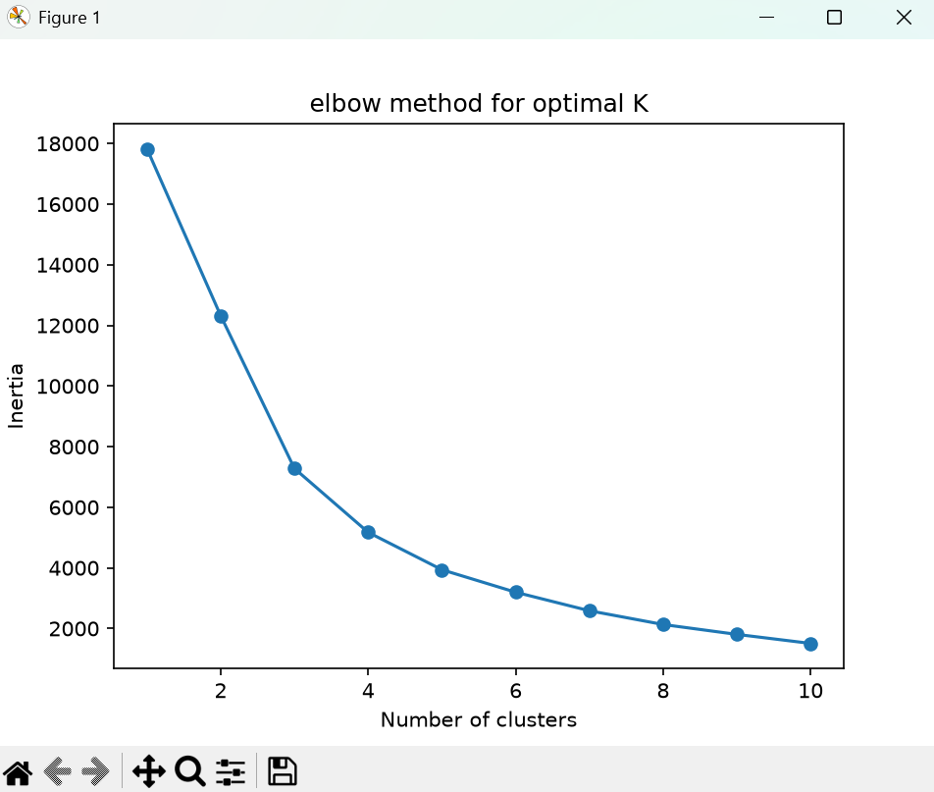
Figure 1. Elbow method — inertia vs. number of clusters.
The curve's steepest improvement runs through K=3-4, flattening noticeably afterward. K=4 was selected over the marginally simpler K=3 because it separates a small group of extreme wholesale outliers (4 customers, ~$422K average spend) from a larger high-value group (42 customers, ~$68K average spend), a distinction with real operational meaning (dedicated account management vs. a loyalty program) that K=3 blends into a single, less interpretable group.

Finding 2: Four Segments and a Skewed Customer Base:
Profiling the average Recency, Frequency and Monetary value within each of the four resulting clusters produced the following segments:
- Core Customers (3,837 customers, 66%) — Recency 65 days, Frequency 8.7 orders, Monetary $2,825 average. The platform's typical, moderately engaged customer base.
- At Risk / Lost (1,954 customers, 33%) — Recency 460 days, Frequency 2.6 orders, Monetary $699 average. Inactive for well over a year on average.
- Wholesale - High Value (42 customers, <1%) — Recency 20 days, Frequency 121 orders, Monetary $67,850 average.
- Wholesale - Extreme (4 customers, <1%) — Recency 3 days, Frequency 257 orders, Monetary $422,093 average.
The two wholesale segments combined represent fewer than 1% of customers, yet their average spend is one to two orders of magnitude above the Core segment, a strong signal that this dataset blends ordinary retail customers with a small number of business/bulk buyers whose needs (and risk profile) differ substantially from the rest of the customer base.
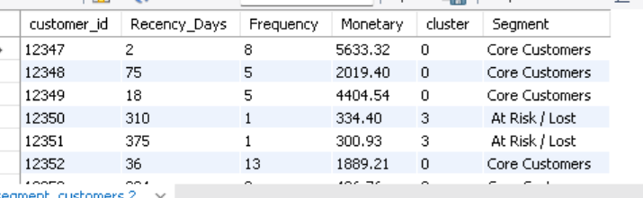
Figure 2. SQL output — individual customer records with assigned RFM values and segment.
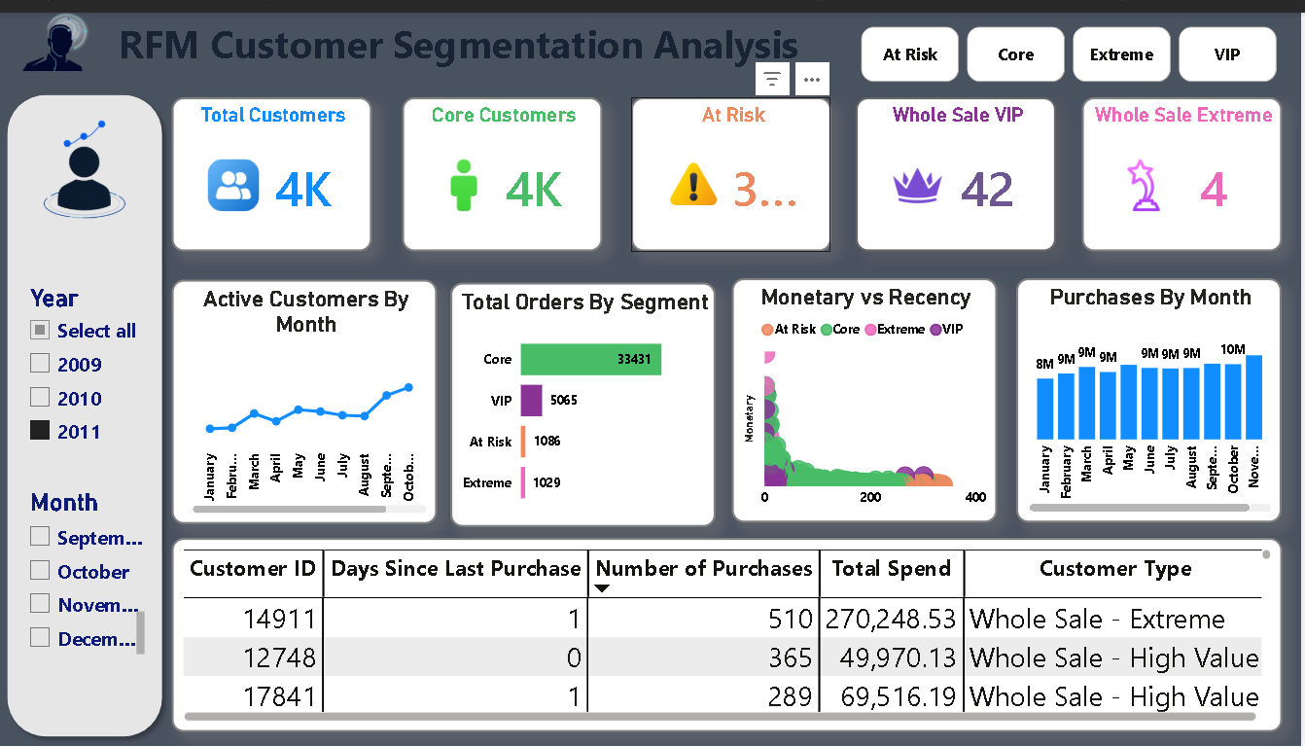
Figure 3. Power BI dashboard — segment KPIs, Recency-vs-Monetary distribution, and monthly activity trends.

Finding 3: A Seasonal Pattern and the At-Risk Opportunity:
Distinct active-customer counts by month show a rise in purchasing activity toward October and November, consistent with pre-Christmas gift buying, a plausible and expected pattern given the retailer's product mix (this was verified against raw transaction dates directly, rather than the Recency metric, to avoid an artifact introduced by Recency's fixed reference-date calculation).
Separately, the At Risk / Lost segment's scale is itself a notable finding: nearly 2,000 customers which is a third of the base who have not purchased in well over a year, despite historically ordering more than twice on average and generating measurable revenue. The dataset cannot explain why these customers stopped purchasing, but the segment's size makes it a reasonable candidate for a targeted re-engagement campaign rather than being written off.

Recommendations:

- Treat the 46 Wholesale customers (High Value + Extreme) as a distinct relationship, not a marketing segment, consider them assigning dedicated account managers to protect and grow the massive revenue they generate.
- Launch a targeted win-back campaign for the 'At Risk / Lost' segment. This group makes up 33% of our customer base and has a proven track record of solid spending.
- Investigate the October–November activity increase further to confirm it is genuine seasonal demand (e.g., against product category mix) rather than assume the cause without additional evidence.
- Resolve cancelled-order handling as a follow-up: incorporate cancellation rate as an additional feature, rather than excluding negative-Monetary customers outright, to avoid discarding potentially meaningful behavioural signal.

Known Limitations & Next Steps:
- Cancelled orders (invoices prefixed "C", carrying negative quantities) were not modelled as a feature in this pass — customers with net-negative Monetary value were excluded from clustering rather than analysed as their own signal. A cancellation-rate feature is a natural extension.
- We calculated customer recency using the final date in this specific dataset. While this works perfectly for our historical analysis, a live system will need to update recency daily using a rolling 'today' format.
- Segment names and K=4 were chosen based on this specific dataset's cluster profiles; both should be re-validated if the model is re-run on updated data, since K-Means' internal cluster numbering is not guaranteed to stay consistent between runs.

Conclusion:
This analysis shows that a small number of customers can carry a disproportionate share of business value and that a large pool of historically engaged customers has gone inactive without an obvious cause — both are directly actionable findings rather than abstract statistics. Combining SQL-based feature engineering with unsupervised machine learning provided a data-driven, defensible way to reach these segments, rather than relying on arbitrary manual thresholds.

Technical Appendix: Supporting Queries:
The following screenshots illustrate representative SQL queries and results from the RFM feature-engineering phase. Full SQL is provided in rfm_queries.sql and the full clustering pipeline in rfm_segmentation_pipeline.py, alongside this report.

Reference Date:
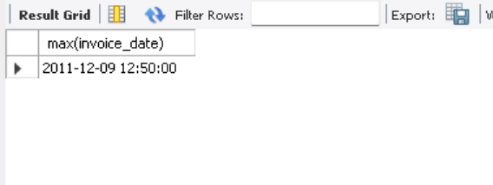
The dataset's latest transaction date, used as the fixed Recency reference point.

Recency:
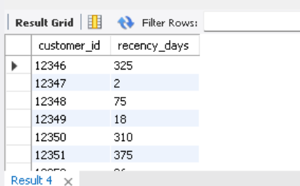
Days since each customer's most recent purchase.

Frequency:
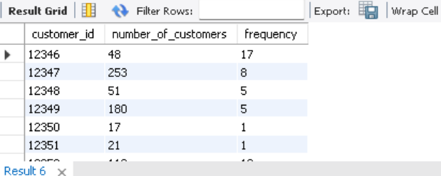
Distinct invoice count per customer (COUNT (DISTINCT invoice), not COUNT (*)).

Monetary:
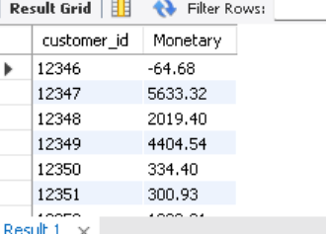
Totals spend per customer, including the negative-Monetary cancellation cases later excluded from clustering.

